**The Impact of increasing Market Uncertainty on yield maturity – Focusing on short-term bonds**

**21600685 cho ye seong**

1. **Introduction**

Unpredictable fluctuations in stock prices in times of crisis, such as the 2008 Subprime mortgage crisis, the 2013 U.S. exit strategy, and the 2015 Greek economic crisis, have been feared by many market participants. This sentiment resulted in market participants increasing their preference for relatively safe assets such as bonds and other non-high-risk items such as stocks and derivatives.

The preference for safe assets(flight to quality) is a financial market phenomenon that occurs when an investor sells what is perceived as a high-risk investment and invests in safer assets, which is usually regarded as a sign of fear in the market. This will have a direct impact on the bond market, as the recent COVID-19 has pushed the base interest rate to near zero, implemented Korean quantitative easing by purchasing large-scale ‘RP’s in addition to the existing base interest rate policy to provide unlimited amounts of money, and recently increased demand for bonds by attempting to directly purchase corporate bonds through the establishment of SPV for the first time in recent years. Increased demand for bonds triggers demand for excess investment in bonds, resulting in higher bond prices and lower interest rates, which in turn results in a decrease in bond yields. To track how these crisis situations increase preference for sale assets and reduce yield to maturity, the study used the measure to measure changes in share prices and to analyze the actual effect of changes in share prices on the yield maturity. The study analyzes the corporate bonds that classified as investment qualification(A- or higher) and short-term treasury bonds(1 year and 3 year) which are represented as safe assets. For corporate bonds, the spread was extracted through a 3 year interest rate and the analysis was conducted on unsecured bonds. For intrinsic volatility, the VKOSPI index, measured by the Korean Exchange, was used based on the variation in the KOSPI 200 index provided by FnGuide.

This study tracked the volatility in bond yields for a total of one year in short-term situations, a period from late May 2019, six months before the outbreak of the COVID-19 to the end of May 2020, six months after the outbreak of the COVID-19, which was considered a crisis situation. The study of intrinsic volatility of the stock market was not directly related to the yield maturity of treasury bonds but it showed a negative correlation to the credit spread of corporate bonds, which are rated as investment qualification. This suggests that in times of crisis, demand for investment-grade, safe-asset bonds will increase sharply over a short period of six months, which could lead to a decline in yields.

1. **Prior Study**

In an existing domestic study, Kim, Park(2009), compared the relationship between the domestic credit spread and the stock market from 2000 to 2007, with the relationship between the corporate bond market and the stock market and the negative correlation between changes in credit spreads and the return on shares has lead to a decline in credit spreads, which as the credit spread decreases, leads to a rise in stock returns while a rise in stock returns has been shown to be a decline in credit spreads.

Cremers, Drisen, Mahout, Weinbaum(2008) also argued that inherent market volatility is significantly related to credit spreads. Jubinsky, Lipton(2011) found that bond yields and spreads show negative relationships from stock market volatility and show a preference for safe assets. Campbell, Taksler(2003) explains that in cross-section regression, volatility has a strong effect, such as bond yield spread as a credit rating. If the amount of change in the intrinsic volatility of the market is measurable, it could eventually be used as an easy tool to analyze the impact of people’s anxious psychology on bond yields and credit spreads.

This study uses the domestic stock price volatility index to reflect the psychological factors people have in crisis situation, which in turn suggests the effect of changes in bond yields on stock price volatility on the rate of return of preference. Based on these findings in the midst of economic crises such as COVID-19, the differentiation of this study is that the investment behavior of domestic bond investors in economically interpretable.

1. **Analytical Method**

In this study, return on short-term treasury bonds(one year, three year) and the credit spread of corporate bonds with investment eligibility ratings (AAA, AA+, AA0, AA-, A+, A0, A-) and variables in the intrinsic volatility index were used. In order to track changes in the pre and post-crisis situation, data from the six months before COVID-19 outbreak(19.05-19.12) and from the six months after COVID-19 outbreak(19.12-20.05) were used and the Korean Exchange, the FnGuide and the Korea Asset Pricing(KAP) were referenced. The credit spread on corporate bonds was calculated by deducting 3 year interest rates on treasury bonds from the 3 year interest rate by corporate bond and all of them targeted unsecured and unguaranteed bonds.

Intrinsic volatility uses VKOSPI provided by the Korean Exchange. VKOSPI refers to the volatility calculated by interpolating each variability calculated from the KOSPI200 option’s recent month and next month on a residual maturity basis using the process variance swap method.

In this stuy, an performed focusing on Bolerslev’s generalized autoregressive conditional heteroskedasticity (GARCH) model to analyze the relationship between stock market volatility and bond yields and credit spreads. $$∆y_{t}=β_{0}+β_{1}∙∆y_{t-1}+β_{2}∙∆V_{t}+ε_{t} | Ω_{t}\sim Student(O,σ^{2})$$

$$σ^{2}=γ_{0}+γ_{1}∙σ_{t-1}^{2}+γ_{2}∙ε_{t-1}^{2}$$

In this above formula, $∆y_{t}$ represents a daily change in bond yields. $β_{0}$ is set as constant $β_{1}$ as the coefficient value of $∆y_{t-1}$ and $Ω_{t}$ as the distribution of Student~t.

The change was calculated in the for of $∆y_{t}$- $∆y_{t-1}$, which deducts the previous day from present day’s yield, and in the case of a spread, the change was set as a dependent variable using the change in the value of the yield on the corporate bond minus the yield on the three-year treasury bond. $∆V_{t}$ means the amount of changes in the VKOSPI index of variability, similarly caculated from present day’s volatility minus the previous day’s volatility.

1. **Results**

A total of nine models were analyzed, with changes in the VKOSPI index, three years of treasury bonds as dependent variables, changes in yields of one year, and changes in the credit spread of corporate bonds(3 years)

1. 3 year treasury bonds

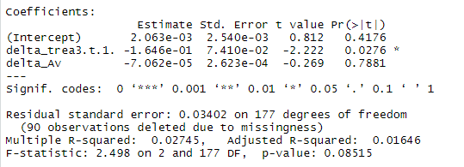

1. 1 year treasury bonds

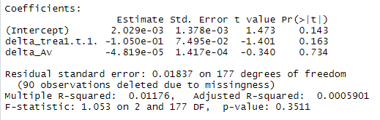

delta_Av of the above variable means the change in the variability index and delta_trea3.t.1 variable means the change in the yield of the treasury bond(3 year) Similarly, the delta_trea1.t.1 variable represents a change in the yield on treasury bonds(one year). In the case of these models, first of all, the p-value of the volatility index was very high above 0.7 which means that in practice the volatility did not have a significant impact on the yield of short-term treasury bonds.

These results suggest that bond market participants are not actually speeding up their purchases of treasury bonds in the face of an economic crisis caused by COVID-19. This can be seen as one of the effects of Korean quantitive easing, as the Bank of Korea released money on the market through massive RP purchases and lowered interest rates to buy treasury bonds, indicating that bond market participants did not actually increase demand for treasury bonds in the face of a crisis in which interest rates fell.

1. Corporate credit spread(3 year)
2. AAA

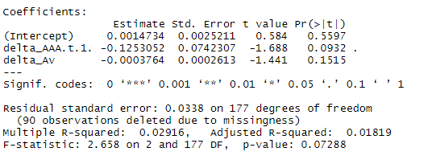

1. AA+

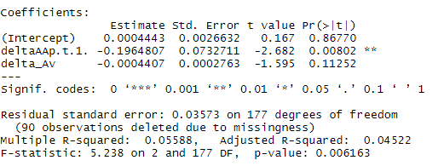

1. AA0

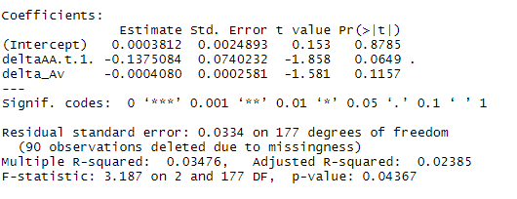

1. AA-

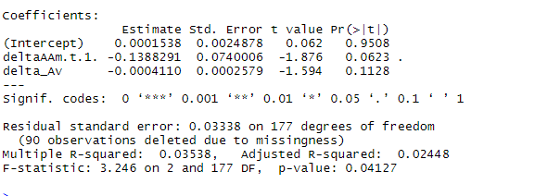

1. A+

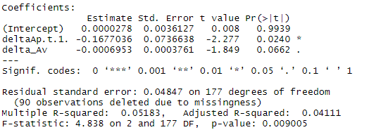

1. A0

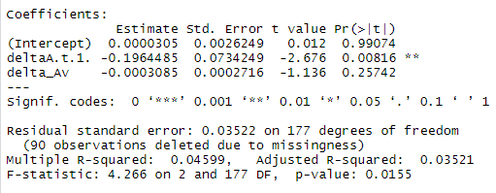

1. A-

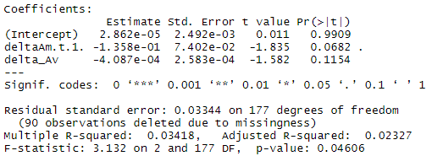

On the other hand, the effect of stock price volatility on the credit spread of corporate bonds shows that all beta coefficients have a negative impact. This shows a pre-emptive preference for safe assets, resulting from higher prices and lower interest rates resulting from increased demand for bonds. Although the degree of impact varies depending on the rating, all investment eligibility ratings above A- can confirm that share price volatility has a negative relationship.

However, since the number of data was only observed before and after the COVID-19 for about a year, the overall p-value of the variable itself did not have a significant level less than 0.05, but in general, it was close to 0.1, so that the meaning of the results of the study could be secured to some extent. This suggests that the effects of volatility can be more significantly observed by extending the duration of a crisis situation and the p-value of the model itself is generally approximated to 0.01 to confirm that the reliability of the model itself has been achieved to some extent.

1. **Conclusion & Discussion**

This study wanted to confirm how people’s anxious sentiment in the short-term crisis situation between May 2019, six months before the COVID-19 outbreaks, and May 2020, six months after the COVID-19, actually works in the safe asset market, especially the bond market. In the case of Korea, as of April, treasury bonds were purchased indefinitely through unlimited quantitative easing, and interest rates on treasury bonds were lowered, so the preference for safe assets in the event of a crisis was not expected to increase the demand for treasury bonds. However, in the case of short-term investment eligible corporate bonds, it was confirmed that demand for corporate bonds increased in the face of a volatile crisis, which eventually led to higher prices and lower interest rates, resulting in a decrease in spread. However, the extent of the impact was minimal due to the short duration of the data. In addition, if the Bank of Korea begins to buy corporate bonds in the future and releases more money on the market, the volatility index may not be affected as in the case of treasury bonds.

However, the study had a very short period of analysis and a small number of analysis samples. Overall, the significance of the beta coefficients in the statistics, especially the volatility index, is not less than 0.05 percent on the basis, making it somewhat unreasonable to conclude with only the results of the model. However, it can be expected that the short-term and deficient data produced a p-value of 0.1 will produce more meaningful results if the data is expanded and extended to include various other crisis situations in the analysis. In addition, these findings will allow a more detailed analysis of changes in the bond market and actions of market participants in times of crisis, making this study easier to identify the flow of economi conditions.